Overview
( HC-LED DISPLAY )

Double-click 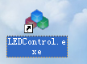 Open software

1 First step：Option ——> Get parameters
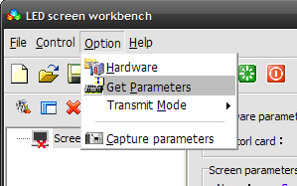

Now, show you how to build a program for simple text
1.Clickto build a new program
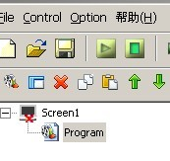

2.Click to build a new window
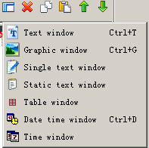
3.Click
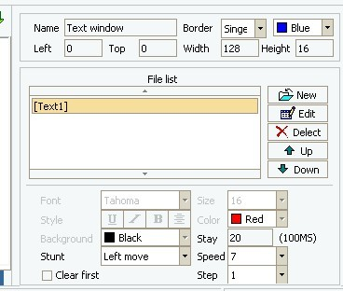

4.Click
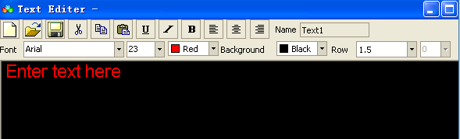
Enter text and click to save
We can choose stunt and speed here
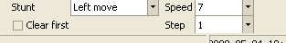

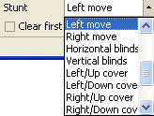
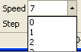
5.send
Clickto send text to the screen
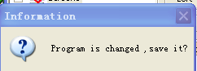
Choose “ok” and save it.
6 close the software

Special Note：
If you have technical questions, we will promptly assist you, thank you!

.led-billboard.
2009.05.05

